JavaScript and Python Comparison
These two languages used in both scripts provided are both very common languages used in modern-day software development and engineering. Each programming language offers different tools and techniques provided in their vast collection of libraries and add-ons to help provide different approaches into the development world. This critical comparison aims to pick apart each language, Python and JavaScript, into their structure and architecture, its simplicity and usability, how to handle errors and debugging and then finally real-world use cases and where each language thrives.
Starting off with Python. Python is a high-level and object-oriented programming language (Python, No Date). Object-oriented programming is the use of classes where classes are created and then called upon (instances) allowing for ease of maintenance and upgrades of the code. Each class offers a range of functions available to be called upon when an instance of that class is created. An example would be if we had created a class In the Python script called ‘name_class’ and then placed the ‘process_name’ function inside of it to be called on later. We could then create to object by assigning a variable to the name_class and then called the method by assigning your data to the ‘.process_name()’ method. Benefits of OOP are as follows: modularity, reusability, productivity, easily upgradable/ scalable, security, flexible, ease of maintenance and Lower cost (Gillis, 2024).

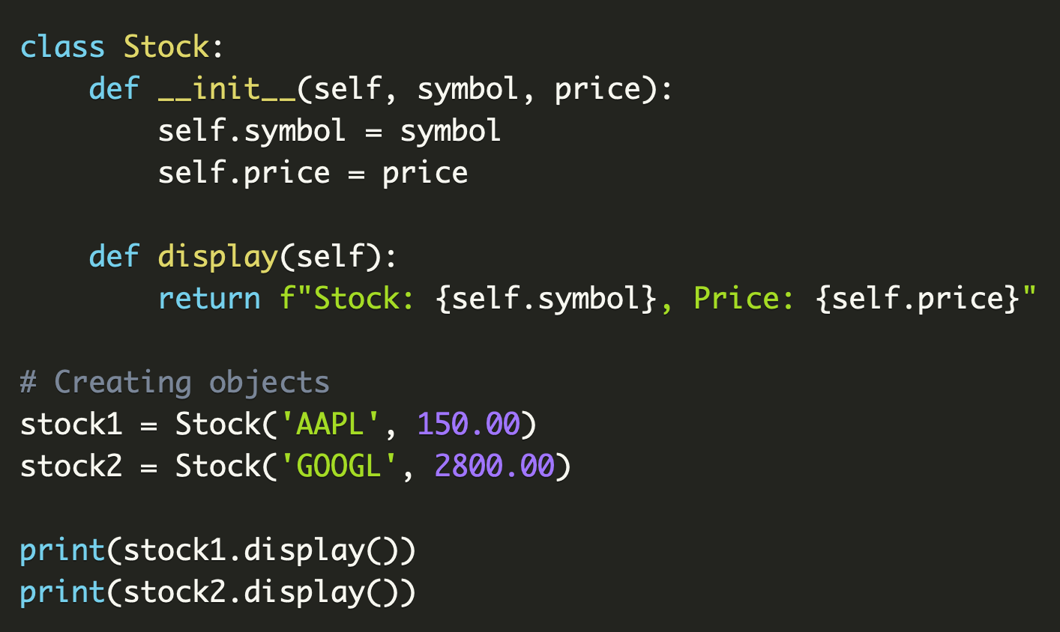
Figure 1: Example of OOP in Python language (Rajandran, 2024)
JavaScript is a client-side programming language that predominantly operates in the interactivity of web pages working alongside HTML and CSS to provide web services (AWS, No Date). Being a client-side programming language, it operates at the front-end closest to the user enhancing user experience (UX). JavaScript operates as a multi-paradigm language meaning it does not use just one architect of programming but multiple depending on the developing aim. Although it does support OOP the same as Python It offers others such as event-driven, functional programming, asynchronous and a couple more. Benefits of JavaScript are as follows: platform independence, reduced server load, improving user interface, supports concurrency and as well as Python is easy to learn (AWS, No Date).
Python is often known for its simple beginner-friendly syntax allowing it to be more readable and easier to develop with due to its clear syntax.

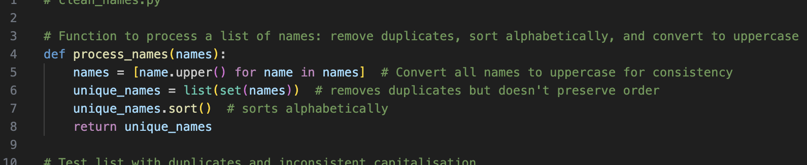
Figure 2: Python code example defining a function
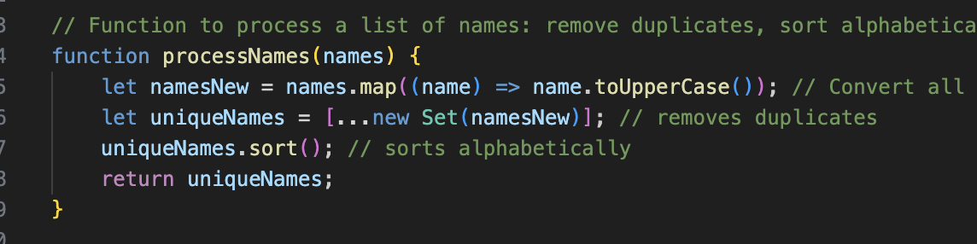
Figure 3: JavaScript code example of defining a function
As seen above in a side-by-side comparison of the two languages performing the same result. The shows the simplicity of Pythons developing structure. Python operate most of its statements and function in a ‘tab’ layout meaning once a function or statement is defined everything below that is tabbed under the ‘parent’ declaration. Whilst JavaScript is the same in the tab perspective there is also additional steps to take in terms of opening and closing the defined step with { / } and placing ‘;’ at end of each line. Although these are small example and simple difference for less experience coders or switching from one language to another these can easily be forgotten or misplaced. This increase in additional code can act as supporting evidence into how when larger code examples are written Python comes out on top for readability and simplicity with its close to plain-English syntax. On the other hand, majority of Pythons command or simplicity does also affect the developing of code. With JavaScript having a looser more adaptable syntax allowing for multiple ways to create code that produces the same output whereas Pythons simplicity usually a few or even just one way of producing the output which gives it less flexibility. They both offer different characteristics and depending on your desired project can offer benefits for performance and scalability depending on where each language is used.
Both languages offer their own individual methods for error handling which conceptually offer the same method of approach where essentially a piece of code is wrapped in an error handling wrap around and then a statement is handled at the end that tells the code what to do if a certain error is found. These in Python are known as the try and except where the code you want to ‘try’ is placed under the try method and then if an error is found or a certain known error can be specified and under the exception will be a piece of code to carry out if this is found. Where JavaScript follows the same process but using Try and Catch as an alternative.
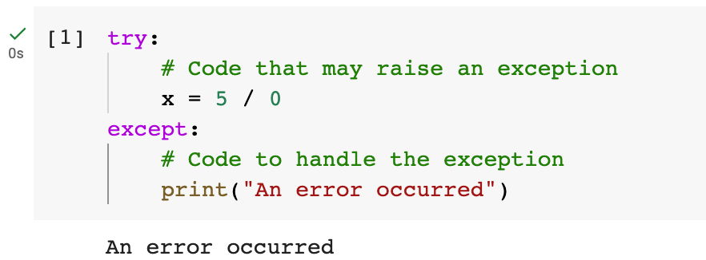
Figure 4: Python error handling (Tao, 2023)
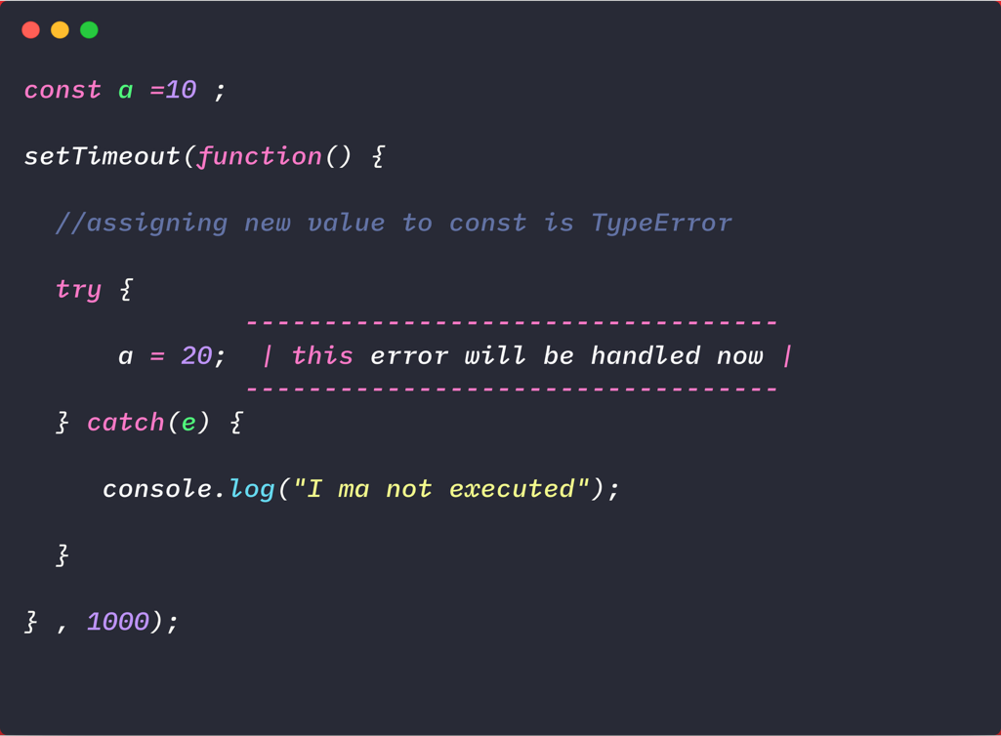
Figure 5: JavaScript example of error handling (Bellon, 2021)
A very similar layout to each of the error handling code examples. These can be used to accommodate every type of error whether you are predicting them or covering from past issues. You can define the specific error message if known or just print a generic error message. For debugging in these Python uses clearer and straight forward syntax allowing it to be more easily followed and predictable output. As well as that it provides clear descriptive error message to allow developers to dial into what is up with their code. JavaScript can be less straight forward just to it being front-end language and some faults can be more hidden. Luckily modern-day integrated development environments (IDEs) come with built in debugging and AI tools to assist with this.
Finally real-world use cases and which language thrives in each sector due to their own unique characteristics. Python is a dominant language in the area of data science and machine learning with libraries such as NumPy, Pandas, and TensorFlow creating its high-demand and popularity especially in the stage of software development we are currently in these libraries in python offer tools for statistics and creating machine learning models and all the tools to help with the data processing. Whereas JavaScript dominates in front-end web development with frameworks such as React, Vue and DOM these offer highly valued frameworks for building and customising user interfaces on web apps. Where both languages cross paths are for the user in backend server logic. With Python having frameworks such as Django and Flask and JavaScript offering Node.js puts both languages in strong positions. Pythons’ backend frameworks come more suited with APIs and machine learning integration where Node.js is great for real-time application such as streaming, social media services and more.
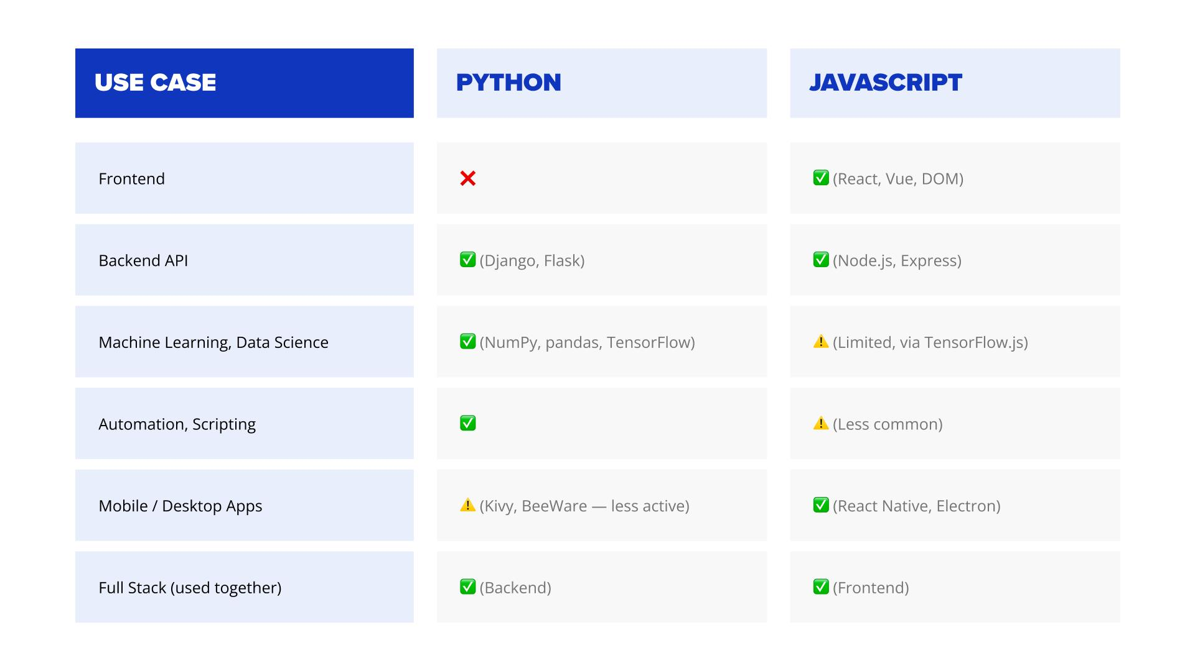
Figure 6: Python and JavaScript use cases table. (Koldovskyy, 2025)
Both languages can be and are commonly used collaboratively in full-stack development cycles. This would commonly use Python for back-end and automation/ machine learning and JavaScript as the front-end interactive user interface.
Drawing a conclusion both languages offer great capabilities with tools and frameworks to assist development and produce the required outcomes. Naturally although the languages overlap and follow similar syntax and layout in some areas of code they are usually used in opposite ends of the development stack with their unique characteristics offering benefits and better suited environments. With experience and wider system knowledge and the ability to decide where the best-case scenario is for the development project being carried out.

References:
AWS. (No Date) What is JavaScript (JS) ? Available at: https://aws.amazon.com/what-is/javascript/#what-is-javascript--74uthw (Accessed: 12/03/2026)
Bellon, M. (2021) JavaScript – Errors and Exception Handling. Available at: https://javascript.plainenglish.io/javascript-errors-exceptions-handling-43ae983cbbb3 (Accessed: 12/03/2026)
Gillis, A. (2024) Object-oriented programming (OOP). Available at: https://www.techtarget.com/searchapparchitecture/definition/object-oriented-programming-OOP (Accessed: 12/03/2026)
Joshi, N. (2024) Python and JavaScript: Finding the best fit for your project. Available at: https://www.taazaa.com/blog/python-and-javascript-finding-the-best-fit-for-your-project#:~:text=Python%20is%20more%20beginner%2Dfriendly,has%20a%20steeper%20learning%20curve. (Accessed: 12/03/2026)
Koldovskyy, V. (2025) Python vs JavaScript: Which programming language to choose in 2025? Available at: https://career.softserveinc.com/en-us/stories/python-or-javascript#:~:text=Both%20languages%20have%20strong%20positions,%3A%20chats%2C%20streaming%2C%20notifications. (Accessed: 12/03/2026)
MDN. (2025) JavaScript language overview. Available at: https://developer.mozilla.org/en-US/docs/Web/JavaScript/Guide/Language_overview (Accessed: 12/03/2026)
Navone, E, C. (2021) Python vs JavaScript – What are the key difference between the two popular programming languages? Available at: https://www.freecodecamp.org/news/python-vs-javascript-what-are-the-key-differences-between-the-two-popular-programming-languages/ (Accessed: 12/03/2026)
PSF. (No Date) What is Python? Executive summary. Available at: https://www.python.org/doc/essays/blurb/ (Accessed: 12/03/2026)
Rajandran, R. (2024) Understanding object-oriented programming (OOP) Concepts in Python for Traders and Investors. Available at: https://www.marketcalls.in/python/understanding-object-oriented-programming-oop-concepts-in-python-for-traders-and-investors.html (Accessed: 12/03/2026)
Samson, H, H. (2024) Error Handling in Programming. Available at: https://www.geeksforgeeks.org/dsa/error-handling-in-programming/ (Accessed: 12/03/2026)
Tao, C. (2023) Exception Handling in Python: from Basic to advanced, Then tricks. Available at: https://towardsdatascience.com/exception-handling-in-python-from-basic-to-advanced-then-tricks-9b495619730a/ (Accessed: 12/03/2026)

